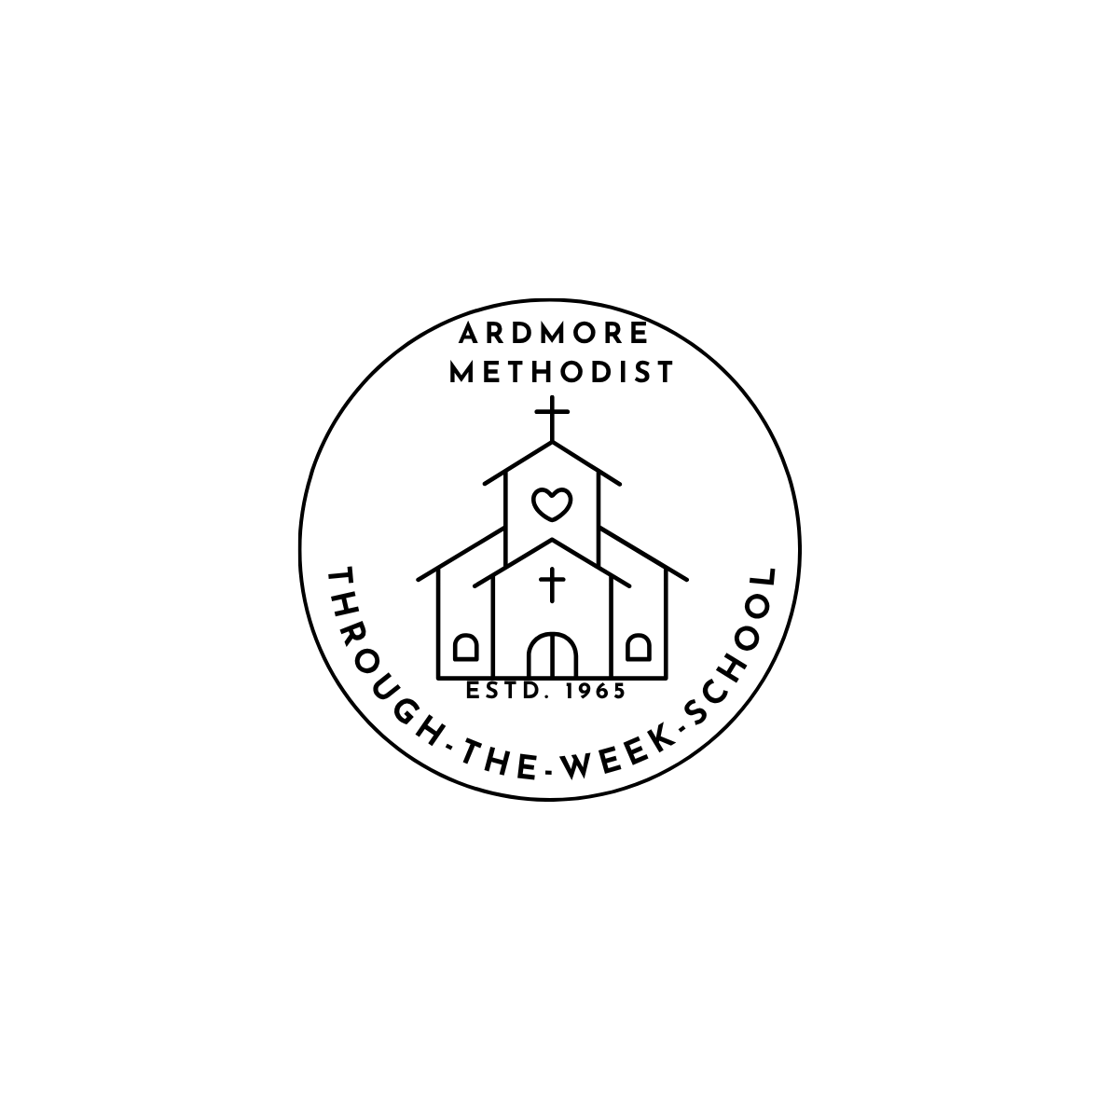
ARDMORE UNITED METHODIST CHURCH
Through-The-Week School
630 South Hawthorne Road
Winston Salem, NC 27103
School Office 336-722-8430
2026-2027 REGISTRATION
To register, complete the attached registration form and return to school with the registration payment. All checks should be made payable to Ardmore UMC TTWS.
Registration Fee for all ages is $150.00 per child, due at registration.
For Fall registration there is a maximum of $320.00 per family.
There is a $45 Activity Fee for the 4-yr-old and Readiness classes to cover the cost of Field Trips.
This is due September 1st.
Registration fees and September tuition are non-refundable
Age cut off date for a class is August 31.

Monthly Tuition Fees
Two days a week | Infants | $240.00
Two days a week | 1-3’s  class | $235.00
Three days a week | Infants | $265.00
Three days a week | 1-3’s  class | $260.00
Four days a week (offer for 4’s class only) | Offered only for 4’s class | $290.00
Five days a week | Infants | $345.00
Five days a week | 1-4’s  class | $340.00
Readiness Class: 9am-1pm (Based on interest) | $440.00
Tuition is paid a month in advance on the 10th of each month
September tuition is sent by June 1st
October tuition is sent by September 1st
Families with more than one child receive a 5% discount per child. Tuition checks may be left in the TTWS Office, or paid directly on Brightwheel. A fee of $15.00 is charged for each returned check

REGISTRATION INFORMATION
Insurance Coverage for each child will be paid by the school from your registration fee.
A medical form must be completed by your family physician and be in the hands of the Director by the first day the child attends Ardmore United Methodist TTWS.
Classes for all ages are in session from 9:00 to 11:55 a.m.

∙ INFANTS & TODDLERS (babies beginning at 6 weeks through toddlers that are one-year-old)
Classes available M-F, MWF or Tue/Th
∙ TWO-YEAR-OLD PRESCHOOL classes available M-F , MWF or T/Th. All classes include Music once a week.
∙ THREE-YEAR-OLD PRESCHOOL classes meet 5 days M-F, MWF or T/Th. All classes include Music once a week. It is our policy that your child must be toilet trained to enter a three-year-old class. If this poses a problem, please talk to the Director. We will evaluate each request on an individual basis.
∙ FOUR-YEAR-OLD PRESCHOOL classes meet 5 days or 4 days a week M-F ,M-TH. Classes include Music once a week and offsite field trips throughout the year. A $45.00 Activity Fee helps cover the cost of field trips.
READINESS CLASS This class is for children who are not yet ready to enter kindergarten. Class meets 5 days a week, M-F, Lunch Bunch is included. Classes include Music once a week and offsite field trips throughout the year. A $45.00 Activity Fee helps cover the cost of field trips.
A monthly Chapel Program is provided for the 2-5-year-old classes.
ADDITIONAL PROGRAM
LUNCH BUNCH: Every afternoon from 12:00 p.m. to 12.55 pm.
o Your child must bring their own lunch and beverage. Please label your child's lunch with their name, teacher’s name, and note any food allergies.
o A fee of $7.00/day per child is charged and you will be billed monthly bills are sent on Brightwheel at the first of the month. Ex:September's Lunch bunch will be billed Oct 1.
o Lunch bunch is not offered the first school day of each month due to TTWS Staff meeting.
o You must pick up your child no later than 1:00 p.m.
LATE FEE FOR LUNCH BUNCH pick up is $7.00 for the first two times and $14.00 thereafter.

ARDMORE UNITED METHODIST CHURCH
Through-The-Week School
630 South Hawthorne Road
Winston Salem, NC 27103
336.722.8430

REGISTRATION FORM
Childs Name_______________________________ Today’s Date__________________________
Name Goes By _____________________________ Male □ Female □ Birthdate ___________
Home Address______________________________________________________________________
Parent 1’s Name _____________________________________ Cell Phone ____________________
Parent 1’s Address _________________________________________________________________
Occupation ____________________________________________Work Phone ________________
Email Address ____________________________________________________________________
Parent 2’s Name _____________________________________ Cell Phone ____________________
Parent 2’s Address _________________________________________________________________
Parent 2’s Occupation ____________________________________Work Phone _______________
E-Mail Address ____________________________________________________________________
Please check program desired:
□ Five-Year Readiness Class 5 Days □ (9-1 pm, Lunch Bunch included)

□ Four-Year-Old Preschool 5 Days □ 4 Days □

□ Three-Year-Old Preschool 5 Days □ 3 Days (Mon/Wed/Fri) □ 2 Days (Tue/Thu) □

□ Two-Year-Old Preschool 5 Days □ 3 Days (Mon/Wed/Fri) □ 2 Days (Tue/Thu) □

□ Toddler Preschool 5 Days □ 3 Days (Mon/Wed/Fri) □ 2 Days (Tue/Thu) □

□ Infant Preschool 5 Days □ 3 Days (Mon/Wed/Fri) □ 2 Days (Tue/Thu) □

Brothers and Sisters _______________________________________ Ages__________
Child's Doctor ___________________________________Phone_____________________________
EMERGENCIES: If parents cannot be reached call:
Must be local
Name ____________________________________________Phone __________________________
Name ____________________________________________Phone __________________________
Allergies or Special Needs (please list and/or explain) ____________________________________________________________________________________________________________________________________________________________________
Previous Preschool Experience Yes □ No □ ___________________________________________
Special Interests ___________________________________________________________________
Challenges/Fears___________________________________________________________________
Additional Comments about your child_________________________________________________
__________________________________________________________________________________
What would you like to accomplish with your child this year?
1. _________________________________________________________________________________
2. _________________________________________________________________________________
I give my permission for emergency treatment (if neither parent can be reached).
Hospital Preference: Novant Forsyth Medical Center □
Atrium Wake Forest Baptist Health □
Other □
Specify ____________________________________________________________

Parent's Signature ____________________________________________________
Date _______________________________________________________________
Registration Fee ($150) Paid? _______________

